

**CU6051 Artificial Intelligence**

*Garden Robot*

Name: Chiemela Oluchukwu Ndukwe & Isaac Furieri

ID Number: 21034871, Isaac’s ID

Date: Wednesday, 25 January 2023

Lecturer: Dr Fiona French

# Declaration

**Module:** CU6051 **Deadline:** 3pm Monday 13th January 2023

**21034871**

**Module Leader:** Dr Fiona French **Student ID:** ________________________

**PLAGIARISM**

You are reminded that there exist regulations concerning plagiarism. Extracts from these regulations are printed below. Please sign below to say that you have read and understand these extracts:

Student signature: ______________________ Date: 25/01/23

This header sheet should be attached to the work you submit. No work will be accepted without it.

Extracts from University *Regulations* onCheating, Plagiarism and Collusion

Section 2.3: "The following broad types of offence can be identified and are provided as indicative examples…

1. Cheating: including taking unauthorised material into an examination; consulting unauthorised material outside the examination hall during the examination; obtaining an unseen examination paper in advance of the examination; copying from another examinee; using an unauthorised calculator during the examination or storing unauthorised material in the memory of a programmable calculator which is taken into the examination; copying coursework.
2. Falsifying data in experimental results.
3. Personation, where a substitute takes an examination or test on behalf of the candidate. Both candidate and substitute may be guilty of an offence under these Regulations.
4. Bribery or attempted bribery of a person thought to have some influence on the candidate's assessment.
5. Collusion to present joint work as the work solely of one individual.
6. Plagiarism, where the work or ideas of another are presented as the candidate's own.
7. Other conduct calculated to secure an advantage on assessment.

(viii) Assisting in any of the above.

Some notes on what this means for students:

1. Copying another student's work is an offence, whether from a copy on paper or from a computer file, and in whatever form the intellectual property being copied takes, including text, mathematical notation and computer programs.

2. Taking extracts from published sources *without attribution* is an offence. To quote ideas, sometimes using extracts, is generally to be encouraged. Quoting ideas is achieved by stating an author's argument and attributing it, perhaps by quoting, immediately in the text, his or her name and year of publication, e.g. "e = mc2 (Einstein 1905)". A *references* section at the end of your work should then list all such references in alphabetical order of authors' surnames. (There are variations on this referencing system which your tutors may prefer you to use.) If you wish to quote a paragraph or so from published work then indent the quotation on both left and right margins, using an italic font where practicable, and introduce the quotation with an attribution.

# Summary/Abstract

This document will give you a brief in the contribution of artificial intelligence in agriculture. As agriculture is a major sector in any thriving economy, it is important to find a way to sustain this important sector. One way to make this sector more sustainable and efficient is to use artificial intelligence. In this current day and age, we have found ourselves to be reliant on computer equipment and machinery to detect if the soil contains all necessary nutrients that a crop needs. We have built specific agricultural technologies that can sense the health of fruit crops or determine if the crops needs something like insecticides or if they need additional organic manure using sensors; some agricultural technologies are also able to harvest the crops using actuators but all these things are with the supervision of human being to determine the performance of this technologies and these technologies are not concerned with what is happening in their environment. That is what this project is going to try to solve. In this project, my partner and I are going to build an agent that can do most of the agricultural task without being monitored by human. This agent will be able to check its performance, know what is happening in its environment and act upon it, use sensors technologies and actuators to carry out tasks. In this project, we are going to build a software-based AI agent in Unity with C# programming language to illustrate what the agent will do in the real world. In this document you will see the state transition table showing how the agent transitions from one state to another.

**Keywords – Agent, AI, agricultural technologies, performance, environment, sensors, actuators, crops, Unity, state transition table.**

# Table of contents

Declaration 2

Summary/Abstract 3

Table of contents 4

List of figures 6

List of tables 7

Chapter 1  8

1.1 Introduction and rationale 8

1.2 Aims 8

1.3 Objectives 8

1.4 Expected Outcomes and Deliverables 9

1.5 Methodology 9

1.6 Background research 9

1.7 The report structure 11

Chapter 2  12

2.1 PEAS for problem space/environment 12

2.2 Performance 13

2.3 Environment 13

2.4 Actuators 13

2.5 Sensors 13

2.6 Mind map 13

Chapter 3  15

3.1 Artifact architecture 15

3.2 Architectural design pattern 15

3.3 Artifact requirements 15

3.4 User requirements definition 15

3.5 Artifact requirements specification 15

3.6 Functional requirements 15

3.7 Non-functional requirements 16

3.7.1 Product requirements 16

3.7.2 Organizational requirements 17

3.7.3 External requirements 17

Chapter 4  18

4.1 Artifact design 18

4.2 Interface design 18

4.2.1 Agent design 18

4.2.2 Crop design 19

4.2.3 Soil design 20

4.2.4 Pest design 21

4.2.5 Farm design 21

4.3 Use-case diagram 22

4.4 Class design 15

4.4.1 UML class diagram 17

4.5 State Machines 23

4.6 State transition table 23

Reflections / challenges identified 52

Reference 53

# List of figures

Figure 1. IoT-based monitoring and control of greenhouse cultivation environments. 7

Figure 2. Mind map 13

Figure 3. Layered architecture pattern diagram 14

Figure 4a. Interface design 17

Figure 4b. Interface design 17

Figure 5. Agent design 18

Figure 6. Crop design 18

Figure 9. Farm design 19

Figure 10. Use-case diagram 20

# List of tables

Table 1. Soil state transition table 7

Table 2. Crops state transition table 13

Table 3. Pests state transition table 14

Table 4. Weeds state transition table 17

Table 5. Flood state transition table 18

Table 6. Agent state transition table 18

Table 7. Supported key input 18

# Chapter 1

## 1.1 Introduction and rationale

This project has been carefully considered given the necessity to improve technology machinery in the agricultural sector. Food is a constant demand in our daily lives therefore it is important that we prioritize the quality of produce that comes out from the farms. It is not news to say that artificial intelligence has become an integral part of agriculture. Over the years, agriculture has improved because of the modern equipment that work together as a unit to make analysis of the soil, when to plant, when to apply a specific material, when to make drainage, when to harvest and sends the data to a server for human to make decision based on the data received. In the research section of this chapter, you will see in detail how these technologies work together to increase agricultural yield. It would be innovative also if an agent was able to do all these things and even more without human supervision. This project will be focused on a software-based agent that will be able to utilize the current know technologies to become an intelligent farm agent that knows what to do at every given state to maximize agricultural yield.

## Aims

The aims of this project to build an AI agent specifically for agriculture which will be able to perform some agricultural tasks automatically without human intervention. These tasks include:

1) Surveillance.

2) Improve crop yield.

4) Control flooding.

5) Crop detection and harvesting.

6) Weed detection.

7) Fruit counting.

8) Health monitoring.

9) Growth analysis.

10) Soil analysis.

11) Exhibit rational behaviour.

12) Perform self-check and self-repair.

## 1.3 Objectives

1) The project shall have one agent.

2) There shall be multiple state for the agent to transition from.

3) There shall be a farm designed where the crops will be planted.

4) There shall be plants designed and arrays properly in the farm.

5) There shall be designs which represents the pest that will attack the crops.

6) There shall be flood designs which will represent flooding.

7) Different states shall be built to dictate what the agent should do at every given scenario.

8) Different states shall be built to indicate the different conditions of the crop.

9) There shall be a function to determine the weight and approximate number of the fruits gathered.

10) There shall be a text indication on the corner of the screen that lets the user know what state the agent is in.

11) There shall be a text indication on the corner of the screen that informs the user about what’s happening to the farm.

12) There shall be an indicator that shows the strength of the battery of the agent.

13) The agent shall be able to check its hardware and software condition and be able to fix itself.

## 1.4 Expected Outcomes and Deliverables

What shall be expected at the end of the project is a VIVA power point presentation, a unity program compiled with no errors, the AI documentation which includes the PEAS for problem space/environment, architectural design pattern, use-case diagram, UML class diagram and few more details.

## 1.5 Methodology

The waterfall model shall be used for this project. The waterfall model is a traditional simplest methodology of the software development workflow and the first Process Model which was introduced in 1970. In the Waterfall methodology, the development process looks like a stream, successively passing phases one by one. But the transition from one phase to another occurs only after the completion of the previous one, in other words, each phase must be complete before the next phase can begin which makes it an ideal model for this AI project.

The main disadvantage of this model - a change in one of the phases will entail the inevitable change in all subsequent ones. It means that the Waterfall model is good only for short and easy projects with all the requirements and specifications documents prepared by the software engineer with no room for adjustments (Iuliia Gapunenko, 2022).

**Justification of using Waterfall model for this project**

The project has a predefined scope. All the requirements for the system are already known and clearly stated in this document. This model will state a clear path to follow during the implementation of the various states. The waterfall model gives the developers of this system a clear goal of what to expect at every stage.

## 1.6 Background research

Agriculture began independently about 12,000 years ago in different parts of the globe. The development of agriculture has changed the way humans lived. They switched from nomadic hunter-gatherer lifestyles to permanent settlements and farming. Out of agriculture, cities and civilizations grew, and because crops and animals could now be farmed to meet demand, the global population rocketed—from some five million people 10,000 years ago, to more than seven billion today (NationalGeographic, 2023).

The mechanical structure and devices (software or robots) are all related to agricultural machinery. There are many types of such equipment, from hand tools and power tools to tractors and the countless kinds of farm implements that they tow or operate. Since the advent of mechanised agriculture, agricultural machinery has become an indispensable part of how the world is fed. Agricultural machinery can be regarded as part of wider agricultural automation technologies, which includes the more advanced digital equipment and robotics (FAO, 2022). While agricultural robots have the potential to automate the three key steps involved in any agricultural operation (diagnosis, decision-making and performing), conventional motorized machinery is used principally to automate only the performing step where diagnosis and decision-making are conducted by humans based on observations and experience (FAO, 2022).

**Big Data and IoT in Smart Farming**

Innovative approaches to food production are required as the human population is predicted to be almost 10 billion by 2050. However, the current rate of agricultural yield is way below the expected rate (D. K. Ray, N. D. Mueller, P. C. West and J. A. Foley, 2013).

**Connected Field Sensors and Machines**

“Precision agriculture (PA) is a management concept that recognizes variability within the soil environment and maximizes economic agricultural production while minimizing the environmental impact for a specific location” (T. Krill, 1994). PA is all about applying the particular material at a specific amount at a specific location and right time, which is known as the 4R concept (T. Bruulsema, 2017), (C. Snyder, 2018).

An organization that uses this sensor technology, Yield Technology Solution, places sensor nodes (a group of environmental and soil sensors) at different locations in an agricultural field that communicate with one gateway over local communication system (T. Yield, 2019). The gateway, in turn, connects to the Internet to store and process data in the Microsoft Azure cloud. Their system measures microclimate data from around the farm and uses AI and data science to provide information that helps in making decisions—e.g., when to plant, harvest, irrigate, feed, and protect crops. The system builds a detailed picture of the farm’s microclimate across a range of conditions and delivers these insights to the farmers as current and future predictions.

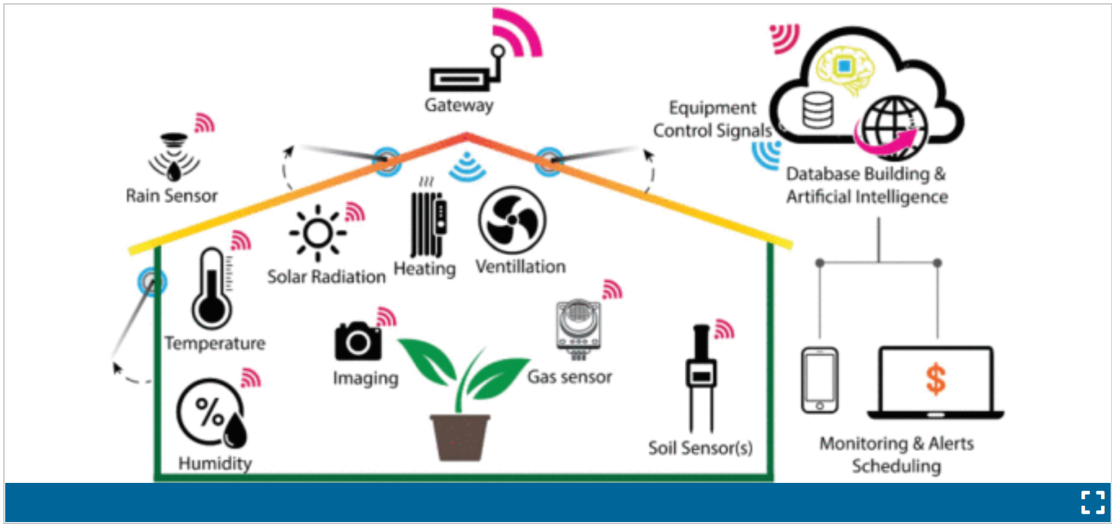

*Figure 1. IoT-based monitoring and control of greenhouse cultivation environments. The greenhouse environment is monitored using a variety of IoT-based sensors, and the automated control is implemented through heating, ventilation, or opening of windows using actuated motors.*

In academic literature, research tackling apple recognition and picking is available since the early 21st century as Bulanon (D. Bulanon, 2000) developed a machine vision software to detect the location of apples on trees. Likewise, research of robotic arms and effectors started to take place relatively at the same period as Setiawan et al. (A. I. Setiawan, T. Furukawa and A. Preston, 2004) developed a gripper that can pick apples without harming the skin.

Apple fruit recognition on trees continued to develop as Bulanon et al. (D. M. Bulanon, T. Kataoka, H. Okamoto and S.-I. Hata, 2004) developed a real-time detection system, Mao et al. (W. Mao, B. Ji, J. Zhan, X. Zhang and X. Hu, 2009) developed a stereo vision to detect also the distance between the machine and apple to be harvested, and Kong et al. (D.-Y. Kong, D.-A. Zhao, Y. Zhang, J.-J. Wang and H.-X. Zhang, 2010) used least-square support vector machine to improve accuracy and speed of stereo vision in detecting apples.

Robotic arm and end effector research continued to improve accuracy and speed of gripping and detaching apples from trees (J. Baeten, K. Donné, S. Boedrij, W. Beckers and E. Claesen, 2008) – (Z. De-An, L. Jidong, J. Wei, Z. Ying and C. Yu, 2011). Silwal et al. (A. Silwal, J. R. Davidson, M. Karkee, C. Mo, Q. Zhang and K. Lewis, 2017) reported the design, integration, and field evaluation of a robotic apple harvester able to detect and pick 84% of the apples with an average picking time of 6 s per fruit.

**Summary**

Now that we have seen some of the technologies that exist which has been specifically designed for agricultural purpose, the AI Farmer which will be designed shall posses most of these technologies relevant to maximize agricultural yield.

## 1.7 The report structure

This report has so far showcased the project intent (section 1.1 – 1.3). Expected outcomes and deliverables are highlighted at (section 1.4). The methodologies that have and will continue to be used for successful completion (section 1.5). The next section after the former is an in-depth look and background research of related work on the project (section 1.5) along with Justification of using Waterfall model for this project (section 1.5) which sums up chapter 1.

Moving forward, the report is broken down into 3 extra chapters starting with an in-depth PEAS for problem space/environment (chapter 2 – 2.1).

Chapter 3, outlines the in-depth artifact architecture (architecture design pattern), artifact requirements definition and specification (section 3.4 – 3.5) and this section also includes the functional and non-functional requirements (section 3.6 – 3.7).

Chapter 4, describes the artifact design which includes Interface design (section 4.2), Data structures design (section 4.3, and more Use-case diagram (section 4.4) also you will see the visual representation of processes such as Unified Modelling Language (UML) diagrams (section 4.5.1). (Section 4.6 – 4.7) shows the state machines and state transition table. Further down, you will see personal reflections and challenges identified during will making this project.

# Chapter 2

## 2.1 PEAS for problem space/environment

The agent shall be autonomous meaning it will be able to perform major farming characteristics without human intervention.

1) Surveillance: Agent shall monitor every crop from animals or human. The agent will send an alert to the control room immediately and will set off an alarm to try and scare the unwanted guests away.

2) Improve crop yield: The agent will achieve this by adding fertilizer or organic manure to the soil.

3) Pest management: The agent will have the ability to do Intelligent spraying that means it will know the type of spray suitable. The agent will know when to spray and how much quantity to spray which will be possible because the agent will be able to check its performance and to know if it got the job done accurately.

4) Control flooding: The agent will be able to know when the farm is flooding and will quickly make drainage for the flood to flow out of the farm.

5) Crop detection and harvesting: The agent shall be able to detect if the fruits are matured enough, healthy, ripe, and ready to be harvested.

6) Weed detection: The agent shall be able to detect the difference between crops and weeds. It shall understand and identify the type of crops that are supposed to grow in the farm and take out other strange crops and send them to the barn where it can make further analysis to understand why the strange crop is growing in the farm and what can be done regarding what type of repellent needs to be manufactured and applied to the soil to stop the weed from growing and will not be harmful to the desired crops in the farm.

7) Fruit counting: The agent shall be able to know how many fruits that were harvested.

8) Health monitoring: The agent shall be able to check and monitor the health of the plant and use available material to revive the crop. This could mean adding more manure or more water to the soil.

9) Growth analysis: The agent shall know at what mature stage the fruit is supposed to be and if a fruit is not reaching that stage then the agent will make analysis to know what needs to be done and does it. After doing the needful to improve the growth, it will check its performance by analysing the growth of the fruit and if the growth is back to normal then it knows that the operation was successful.

10) Soil analysis: The agent shall be able to conduct soil analysis. This is to make sure that the soil is in good condition and has all the nutrients the crops require to be able to produce the expected yield. After making sure the soil has gotten all necessary nutrient, it will check its performance by sensing how damp the soil is, the texture of the soil.

11) The agent needs to be Rational: The agent needs to do the right thing which means determining what to do, and the consequences of actions e.g.:

Checking plants, are the plants desirable for growth?

Yes: proceed to check all plants.

No: There is any hazard in the plant? The soil is good or there is any hazard?

Agent Perception: location and status (States machine).

12) The agent shall be able to check its health state. It shall be able to check its battery health and the internal device components. It shall be able to fun an entire hardware and software check. The agent shall be able to repair itself from any damaged parts or software.

13) The agent shall use vision system to detect where the crops are. It shall also use this vision software to detect where the fruits are on the plant. This way, it can also identify and tell the health state of the fruits.

**In the following sections 2.2 – 2.5, this document will analyse the PEAS for Crop detection and harvesting which is item 5 above. The intent is to help you understand how the agent is supposed to achieve Crop detection and harvesting.**

**Note: The crop used for this demo is the pumpkin tree and the fruits that will be harvested by the agent are a pumpkin fruit.**

## 2.2 Performance

**Safety**

Crop not surrounded by weeds, crop not surrounded by flood, pests not close to the crop, soil colour not black. If the crop does not have these prior conditions, then the agent will know the crops are safe. The agent will run this routine check 6 hours. If the agent learns that one of these things are happening to the crop, then it will act accordingly to save the crop by making sure the identified threat is neutralized.

**Maximize harvest**

If the soil sample taken from the farm contains more than 50% nitrogen (N), phosphorus (P) and potassium (K) which make up the trio known as NPK, then the agent will know that farm yield will be at a maximum. If the soil sample does not meet this base requirement, then it will add more fertilizers to the soil depending on the quantity that is required and will repeat this routine the next day. If the analysis shows that the required nutrient stated above are more than 50% then the agent will do nothing more to improve the soil for that day.

**Accuracy**

The agent will know how accurate it is in harvesting each pumpkin fruit if it follows these harvesting steps:

* Recognize the ripe fruit by using the UAV-Based RGB Imagery for Hokkaido Pumpkin (Cucurbita max.) Detection and Yield Estimation (Lucas Wittstruck, Insa Kühling, Dieter Trautz, Maik Kohlbrecher, Thomas Jarmer, 2020).
* Go horizontally underneath the pumpkin by measuring the distance left and right distance of the pumpkin from the centre of the harvester by using Ultrasonic Sensors (Roderick Burnett, 2020). This is to make sure the pumpkin falls right in the middle of the harvester.
* Cut the stem attached to the fruit using the blade attached to its robotic arm grabbers to clip the stem.

**Harvesting success rate**

The agent will know its success rate if it is able to:

* Perform all the tasks in the **Accuracy** section until their isn’t any ripe fruit left on all the trees.
* Successfully transport the fruits to the store without any fruit falling from the harvester.
* Gently tilts the harvester vertically so that all the pumpkin will roll out and then tilt the harvester back to the horizontal position.
* Use the UAV-Based RGB Imagery for Hokkaido Pumpkin (Cucurbita max.) Detection and Yield Estimation (Lucas Wittstruck, Insa Kühling, Dieter Trautz, Maik Kohlbrecher, Thomas Jarmer, 2020) system to see if it recognizes any pumpkin that might still be in the harvester and if it recognizes a pumpkin, then it will gently tilt the harvester again but this time before it reaches 90° angle, it will use force to jerk the fruit to make it fall.

**System Diagnosis**

The agent will run a system diagnosis before it checks for the safety of the crops, agent will run a system diagnosis before it attempts to maximize harvest, agent will run a system diagnosis before it attempts to harvest the crops, agent will run a system diagnosis before it attempts to offloads the harvested crops, agent will run a system diagnosis after it offloads all pumpkin from the harvester. This diagnosis will check the mobility of the agent, the robotic arm movement, the sensors, the software programs, the inbuilt components. In the case whereby the agent is not able to repair itself or runs out of battery in the middle of the field, then the manual override will be activated by the farmer which will allow the farmer to push the agent to where he can change the battery or replace broken parts.

## 2.3 Environment

The agent’s environment shall always be the farm. The farm shall be where it will reside because it is specifically built for the farm and for the sake of maximizing agricultural yield. The agent will have waypoint GPS round each pumpkin tree to let it know the areas that are not walkable. The agent shall also use this waypoint GPS to know where the pumpkin trees are. The store area will has GPS which will transmit signals to the agent on the fastest route to get to the store.

## 2.4 Actuators

The agent’s actuators shall be:

* A specifically developed robotic arm for this application.
* A developed end-effector for pumpkin.
* A controlling system for the robotic arm.
* Bluetooth device and WiFi connection to the network.
* Balancing systems such as standard farming tyres and wheels as specified by the European Tyre and Rim Technical Organisation (ETRTO). These balancing machines are suitable for balancing the automotive components that need high precision, low noise and a vibration reduction in order to guarantee a safer performance.
* The agent shall be able to check the crop state by: 1) digging its robotic arm about 2cm below its tyre horizontal level, 2) curl its robotic end-effector to a 90° angle to scoop up some soil sample, 3) use the GPS to get the fastest root to the laboratory and finds its way using waypoints, 4) turns its end-effector at 180° and vibrates the end-effector for 30 seconds to make sure the scooped soil is emptied in the laboratory, 5) the agent will connect to the laboratory equipment using Bluetooth and will send a signal to turn on the laboratory equipment (Note: this analysis usually takes 30 minutes. Once the analysis are complete the agent will receive the results over the WiFi) then the agent will go back to the pumpkin tree using the GPS waypoint round each tree, 6) the agent will use its end-effector to determine how hollow it is, 7) the agent shall use UAV-Based RGB Imagery for Hokkaido Pumpkin (Cucurbita max.) to determine the colour of the pumpkin fruit and stem, 8) the agent will use the WiFi to connect to the database and log the condition of the farm terrain, upload its locomotion statistics, upload the results from the soil analysis, upload how hollow the fruit is, upload the colour of the pumpkin fruit and stem, 9) agent will perform calculations on the uploaded data and will draw conclusion based on the data to wither pick out the bad fruit with the robotic arm or to leave it.

## 2.5 Sensors

* The agent shall have UAV-Based RGB Imagery for Hokkaido Pumpkin (Cucurbita max.) Detection and Yield Estimation (Lucas Wittstruck, Insa Kühling, Dieter Trautz, Maik Kohlbrecher, Thomas Jarmer, 2020) for fruit detection, colour detection, stem detection.
* The agent shall have Bluetooth device.
* The agent shall have WiFi to connect to the network.
* The agent shall have GPS to know where the trees are, where the store is, where the laboratory is.
* The agent shall have Ultrasonic Sensors (Roderick Burnett, 2020). This will enable it know the position of the fruit and the harvester so that the fruit fall perfectly into the harvester when it’s harvesting the fruit.
* The agent shall have a date and time installed. This will enable it know when to start its daily cycle.
* The agent shall have thermometer installed to be able to tell the weather.
* The agent shall have Lidar installed. Lidar — Light Detection and Ranging — is a remote sensing method used to examine the surface of the Earth (National Oceanic and Atmospheric Administration, 2023). The agent shall use this sensor to understand the terrain and the earth’s surface to know how to navigate itself.

## 2.6 Mind map

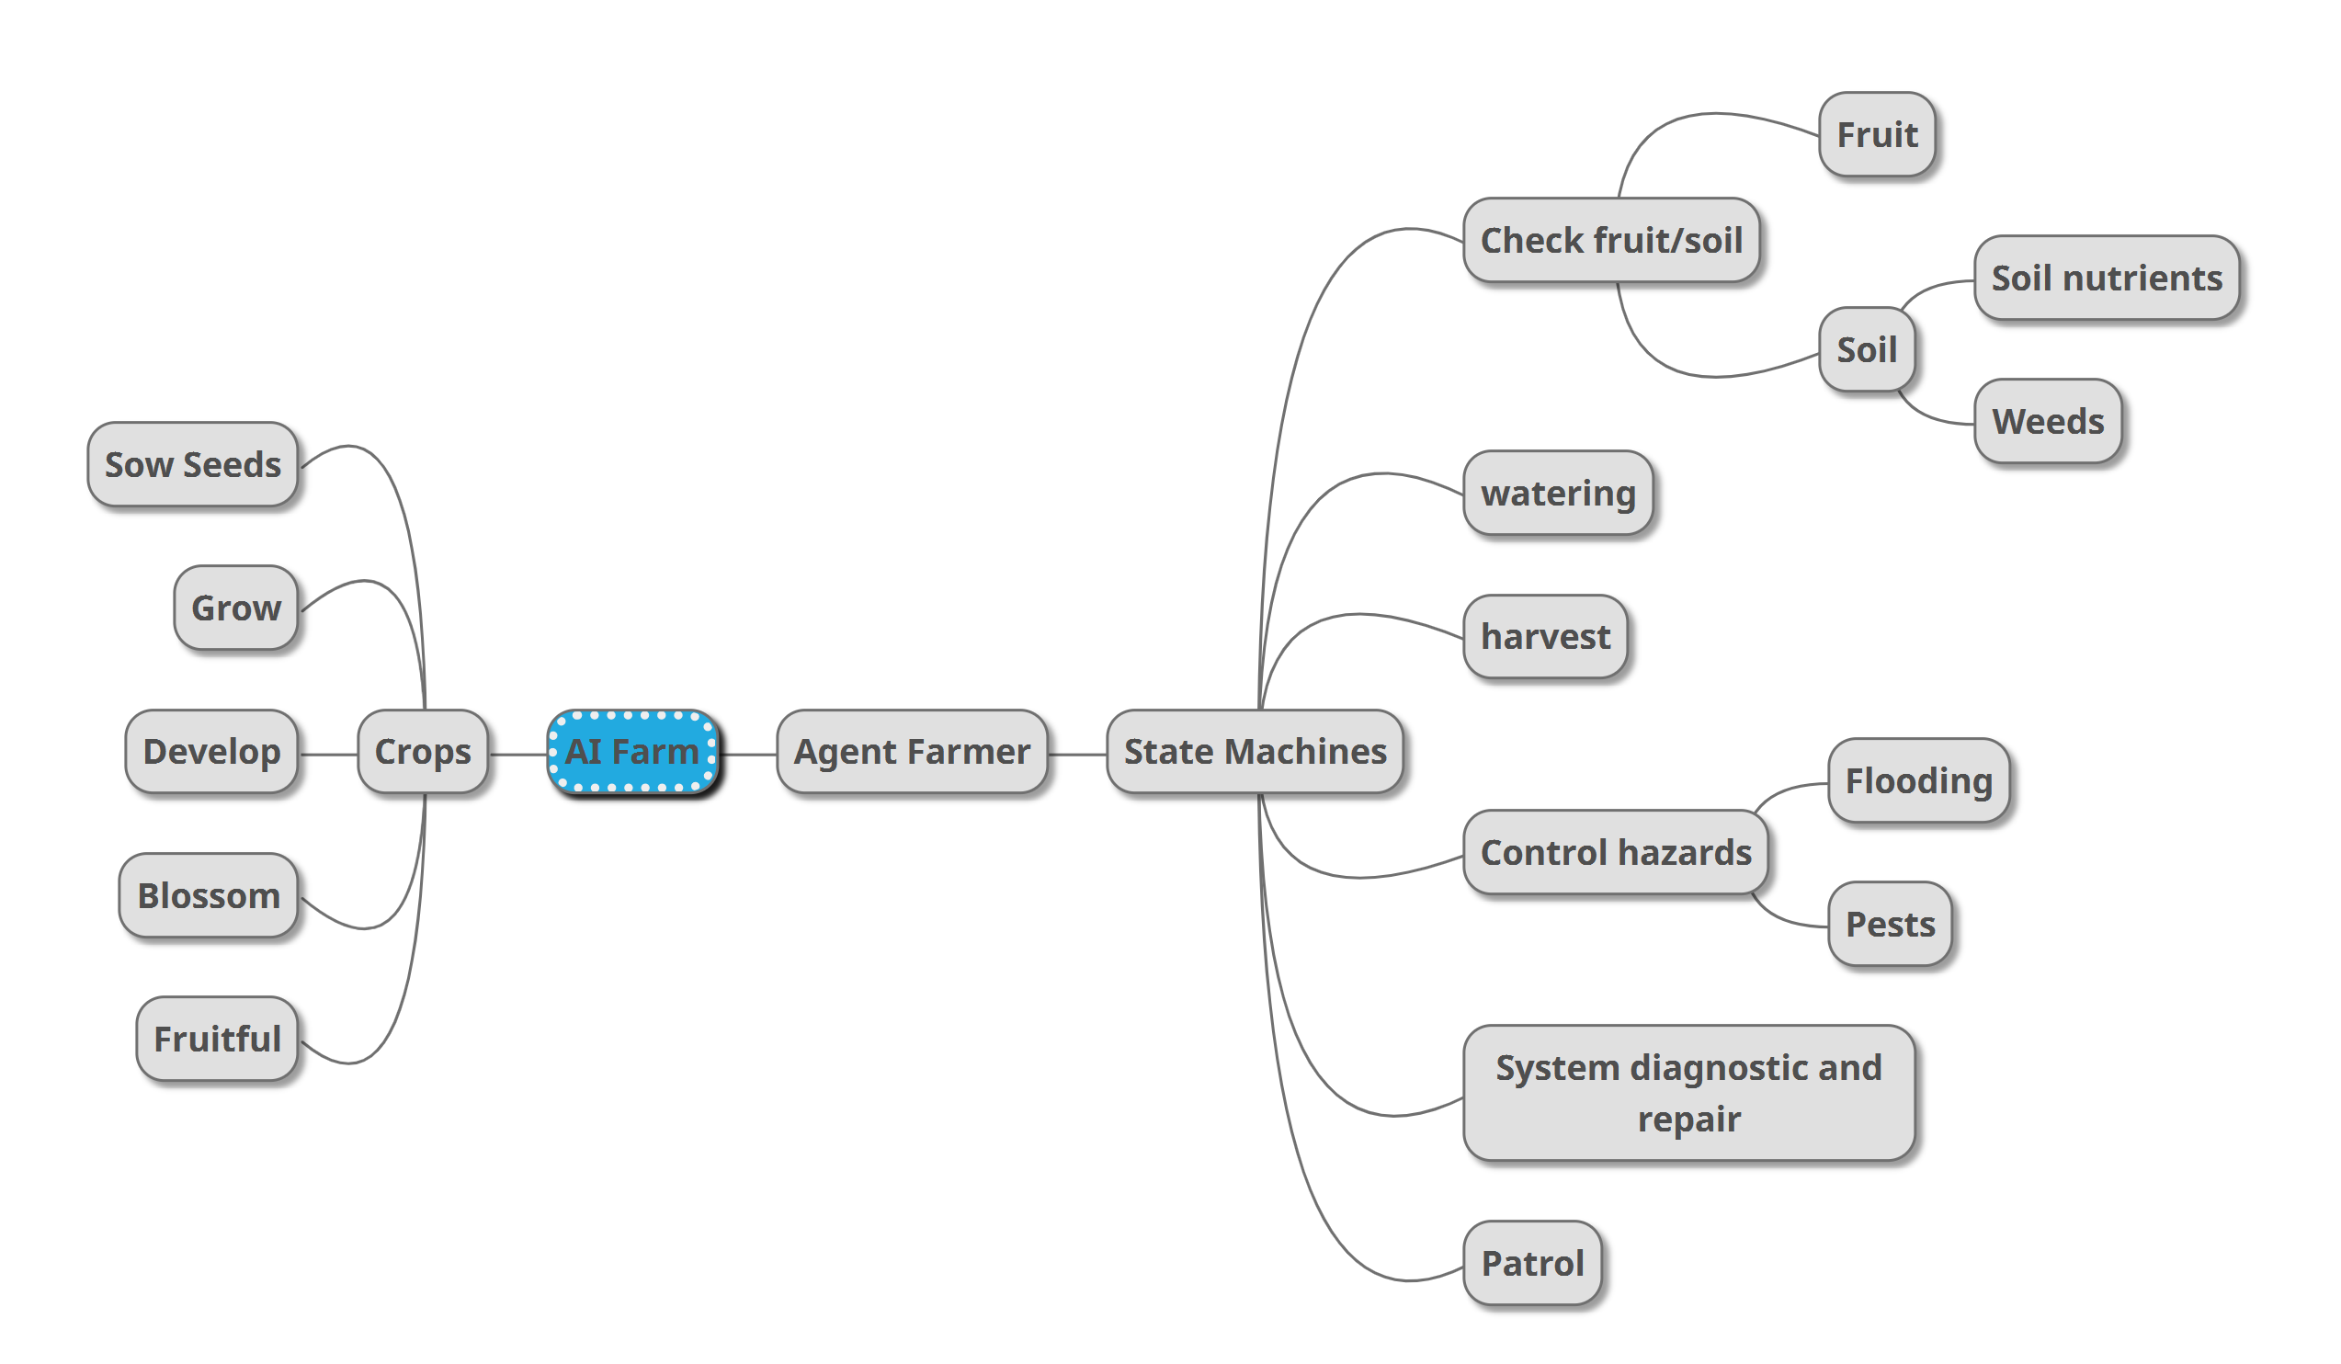

*Figure 2. Mind map*

# Chapter 3

## 3.1 Artifact architecture

Layered architecture is more suitable for this project because it organises the project into layers with related functionality associated with each layer. A layer provides services to the layer above it so the lowest-level layer represents the core state machine scripts that are going to be used by the garden robot.

## 3.2 Architectural design pattern

Layered architecture shall be used for this artifact. Theoretically it is N-tier architecture. So, we can design the environment and the entities in that environment such as the garden robot, crops, pests. The next layer shall be the physics of these entities. The lowest level shall be the states that control the behaviour of these entities. So, for this project we will consider N-tier architecture as 3-tier architecture and try to implement the Garden Robot Artifact.

GUI design

Game engine support library services

State machines and WayPoints

Figure 3. Layered architecture pattern diagram (Ian Sommerville, 2016).

## 3.3 Artifact requirements

The artifact requirements are both user requirement definition and artifact requirement specification for this project which shall be further explained in the following sub-headings.

## 3.4 User requirements definition

A GARDEN ROBOT that reacts to environmental changes.

## 3.5 Artifact requirements specification

The artifact requirement shall be further divided into two parts which shall provide a detail of what requirements needs to be met which includes the functional and non-functional requirements.

## 3.6 Functional requirements

The artifact should provide the following functionality:

1. Protect the crops from flooding.

2. Protect the crops from pests.

3. Harvest the fruits when they are fully matured.

4. Check the soil condition.

5. Check the fruit condition.

6. Repair itself.

## 3.7 Non-functional requirements

Constraints on the services or functions offered by the system such as timing constraints, constraints on the development process, standards, etc. Often apply to the system as a whole rather than individual features or services (Sommerville, Ian, 28/03/2016). This is comprised of the following:

* Product requirements.
* Organizational requirements.
* External requirements.

## 3.7.1 Product requirements

Requirements which specify that the delivered product must behave in a particular way e.g., execution speed, reliability (Sommerville, Ian, 28/03/2016). Product requirements includes the following from item.

**Usability requirements**

* The artifact shall have one agent.
* The artifact shall have text to help the user understand what is happening.
* The artifact shall accept interactions from user via the keyboard.

**Efficiency requirements**

* Sufficient DataTypes shall be used. DataTypes such as: float. Double DataTypes will be considered only on special occations. This is a precaution to reduce memory consumption.
* There shall be no unnecessary background process running on the system to reduce processor workload.

**Performance requirements**

* Artifact shall run on a computer that is fully functional.
* Artifact shall run on a computer that is connected to a functional keyboard and mouse.
* Artifact shall run on a computer with a processor that has 3 cores or higher.
* Artifact shall run a windows-based operating system.

**Space requirements**

* Artifact shall run on a computer with RAM of 6 gigabytes minimum.
* Artifact shall run on a computer with minimum 8 gigabyte free hard disk space.

**Dependability requirements**

* Artifact shall have one general codebase to ensure that the simulations and functions performs the same way for each user.

**Security requirements**

* The computer system should have anti-virus protection to protect the stored data. Preferably Windows Security.

## 3.7.2 Organizational requirements

Requirements which are a consequence of organizational policies and procedures e.g. process standards used, implementation requirements (Sommerville, Ian, 28/03/2016).

**Environmental requirements**

* Anyone can execute the program from a anywhere they are comfortable working with their computer.

**Operational requirements**

* The users of this software shall have a copy of this saved to their machine.

**Development requirements**

* Windows 11 operating system shall be used to build this software which will be where the software will reside.
* Microsoft Visual Studio shall be used as the IDE because it is robust and runs faster than other IDEs.
* Unity 2021.3.6f1 is the version this artifact shall be built with.
* GitHub should be used to help with version control.

## 3.7.3 External requirements

These are factors external to the system and its development process which includes the following subtitles. This external requirement demonstrates the need to protect client’s information and payment/transaction details safely and securely (Sommerville, Ian, 28/03/2016). (Sommerville, Ian, 28/03/2016).

**Ethical requirements**

* The program shall not collect user personal details without user consent.

**Safety/Security requirements**

* The artifact shall be packaged and zipped with MIT License text file which authenticates the artifact.

# Chapter 4

## 4.1 Artifact design

Software Design Specification or software design document or SDD is a representation of a software design that is to be used for recording design information, addressing various design concerns, and communicating that information to the design’s stakeholders (IEEE, 20 July 2009).

## 4.2 Interface design

The interface which will be used for this software will be a environment/world where the agent shall reside. To achieve this, we will build the software using Unity C# and from here we shall compile the program. Below are sketches of the interface design.

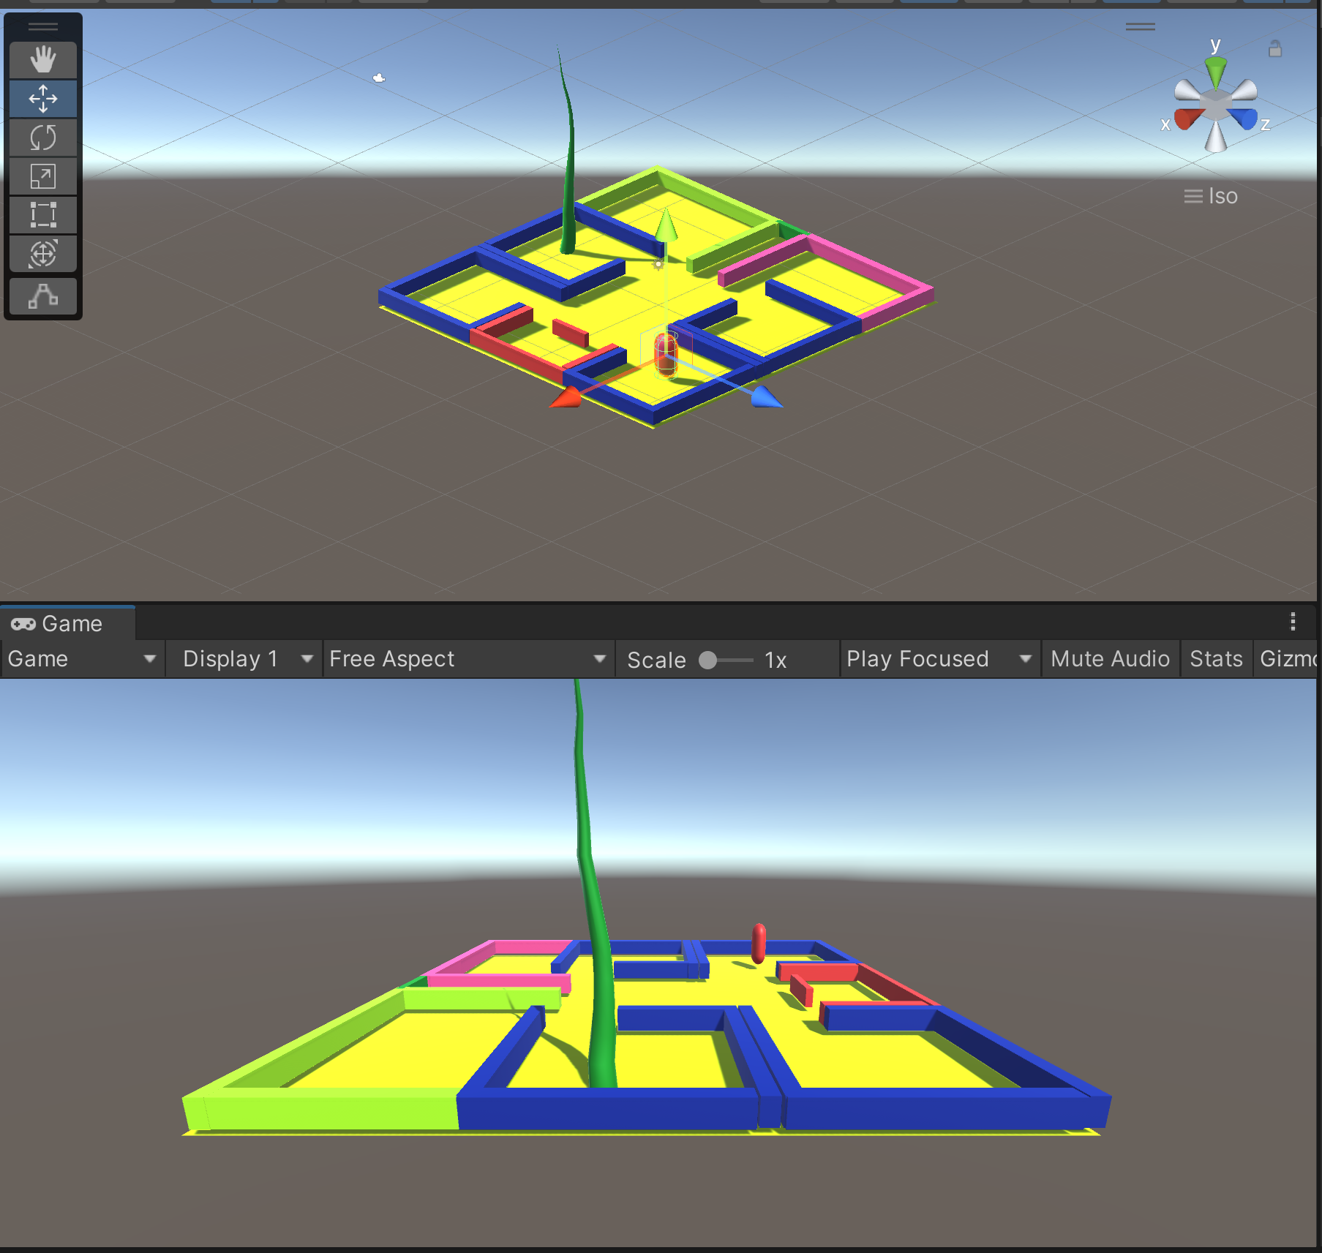

Figure 4a. Interface design

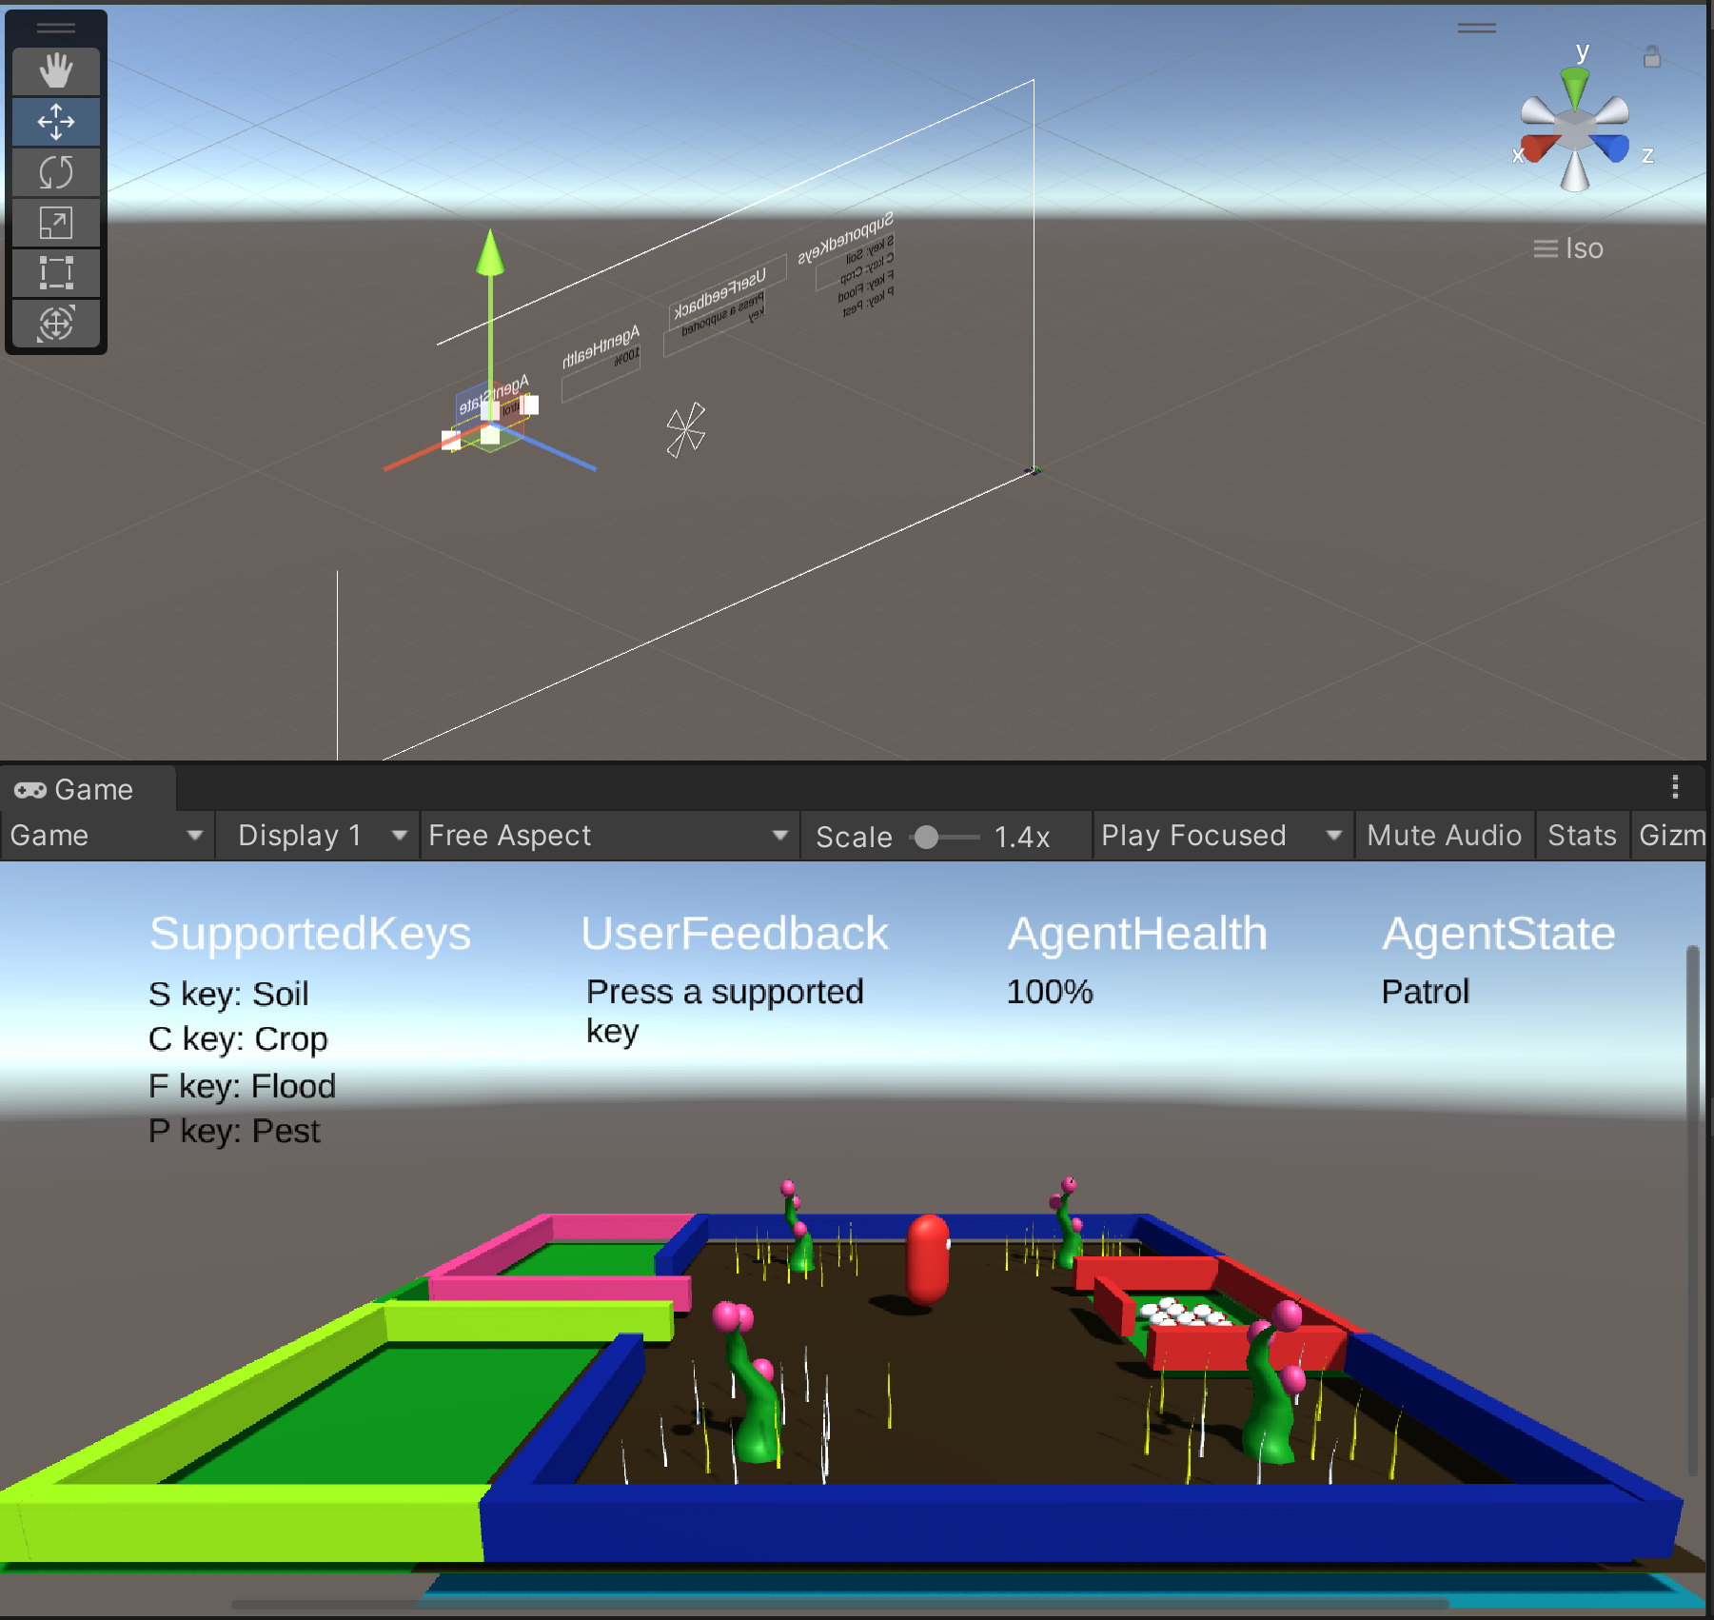

Figure 4b. Interface design

## 4.2.1 Agent design

The agent shall be a 3D Object and shall have a sphere shape. Its shall be shiny red colour. The agent shall have white camera eyes which it shall use for vision to know where it is at all time. It shall use its vision features to detect where the crops are. With this vision feature, it shall know the health of the crop, the health of the soil. The agent shall have sensors that let it know what’s happening in the parameter of the farm. The sensor shall provide the agent with further data about its environment and about its own health state.

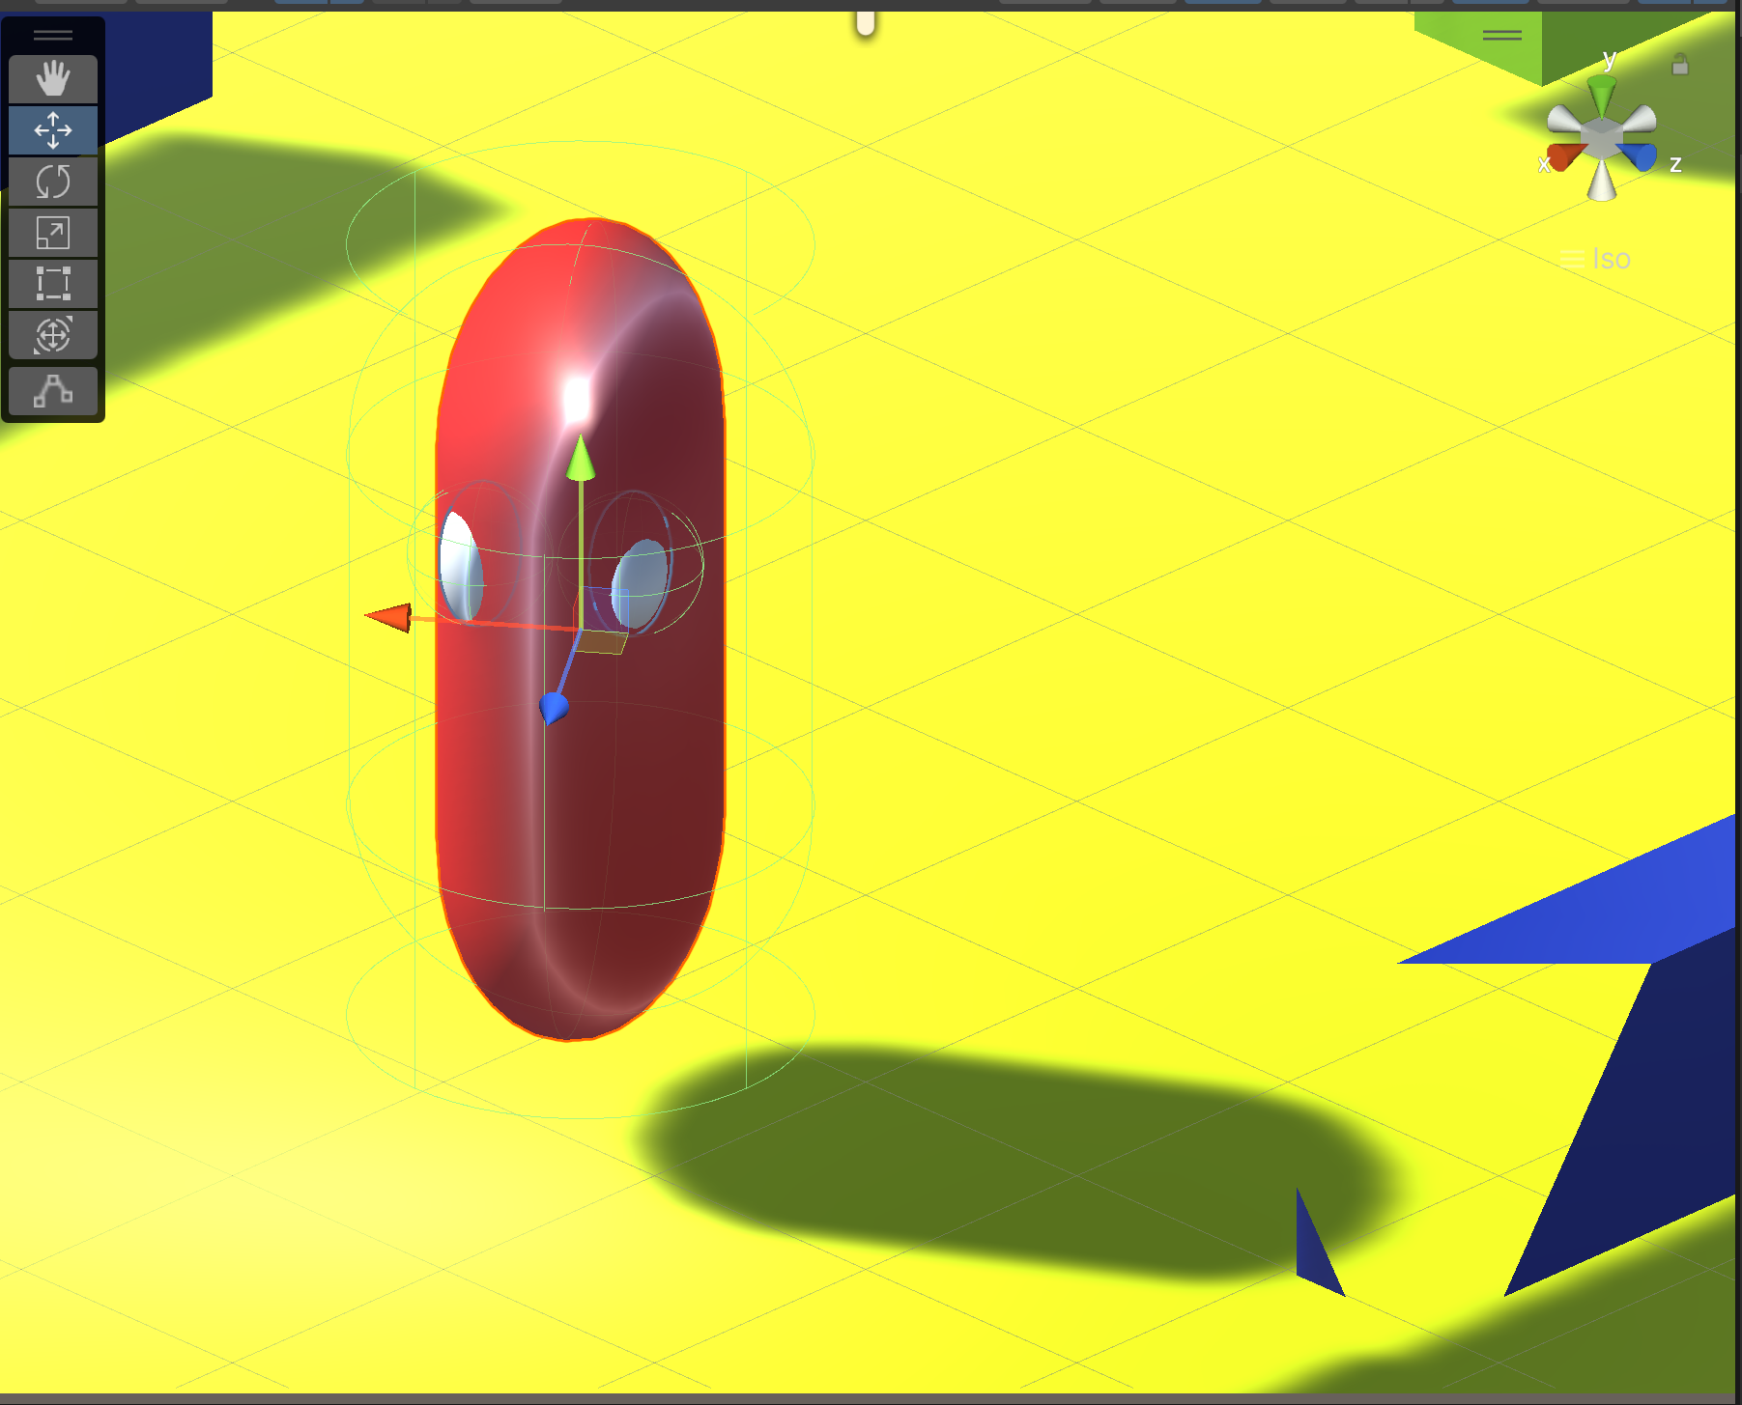

Figure 5. Agent design

## 4.2.2 Crop design

The crop shall have the ability to increase fruit size either over time or by keyboard input from user.

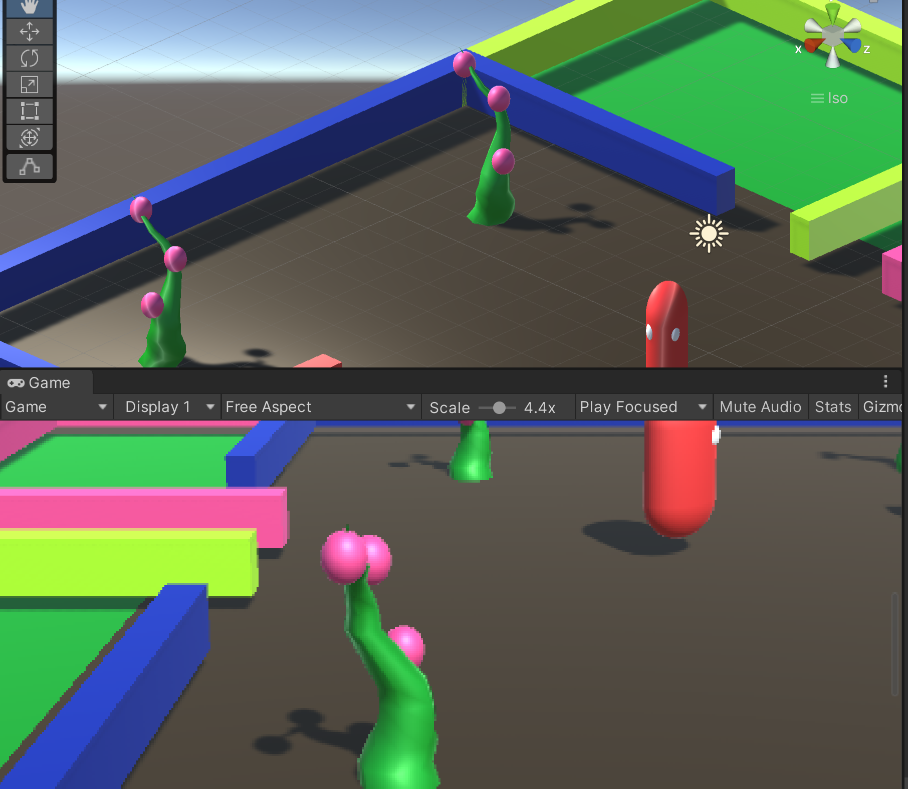

Figure 6. Crop design

## 4.2.3 Soil design

The soil is going to be of a dark brown colour. The dark brown section of the farm shall represent the soil and the area where crops can be planted. The is the soil design.

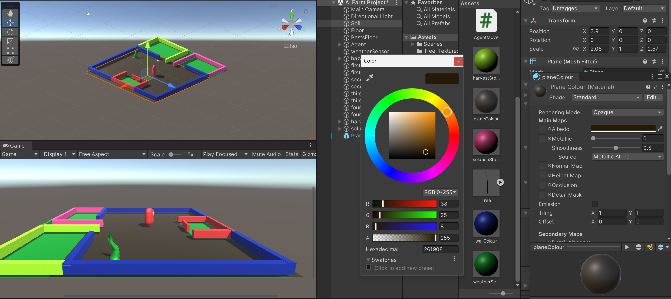

Figure 7. Soil design

## 4.2.4 Pest design

The pest shall be white in colour to contrast with the soil and the crop. The pest design.

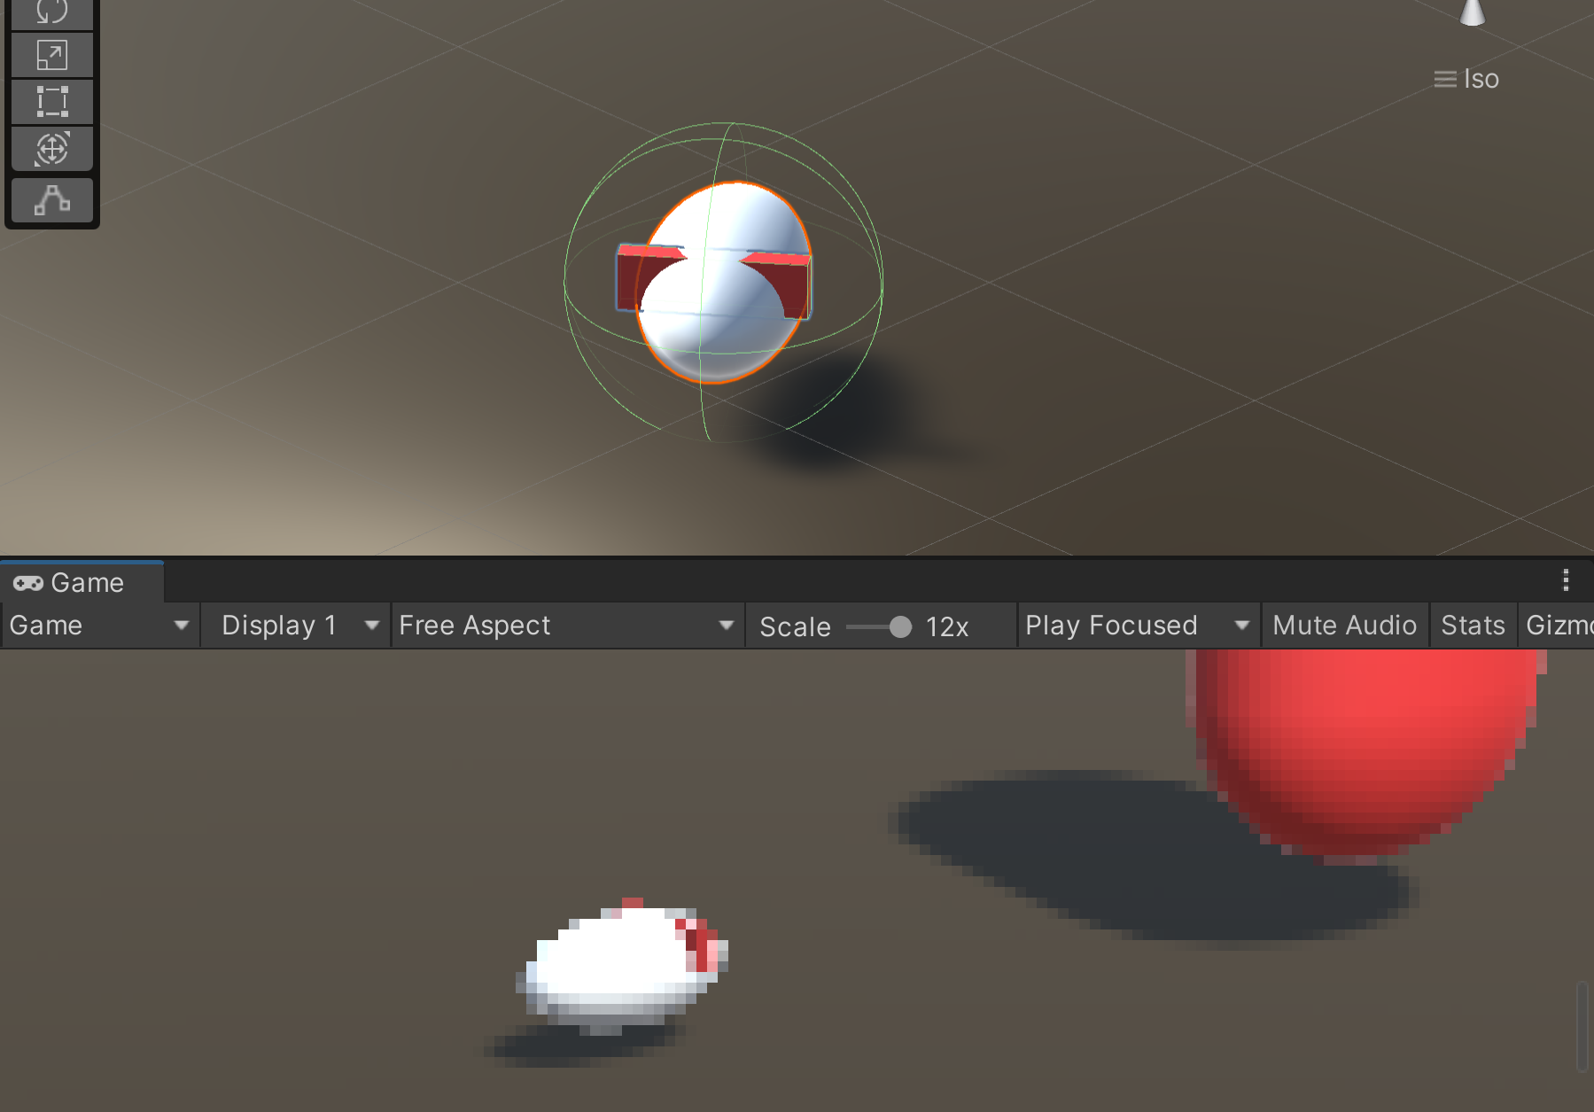

Figure 8. Pest design

## 4.2.5 Farm design

The farm shall have space for the plants, space for the drainage in case of flooding, and space for storing crops.

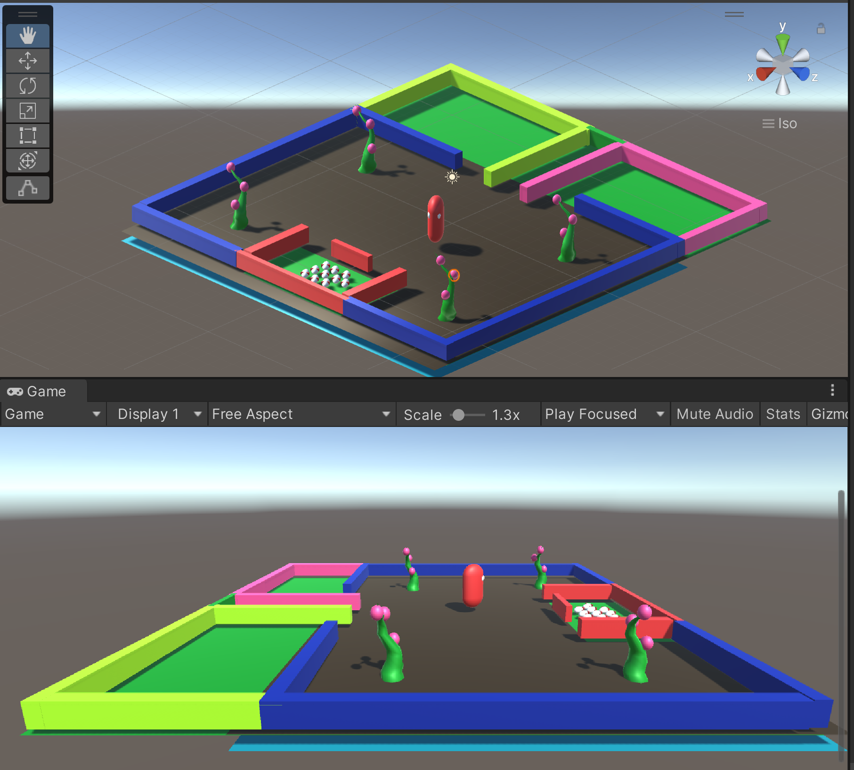

Figure 9. Farm design

## 4.3 Use-case diagram

The below diagram is the Use-case diagram which shows the interaction between the user, the program and the reactions of the agent.

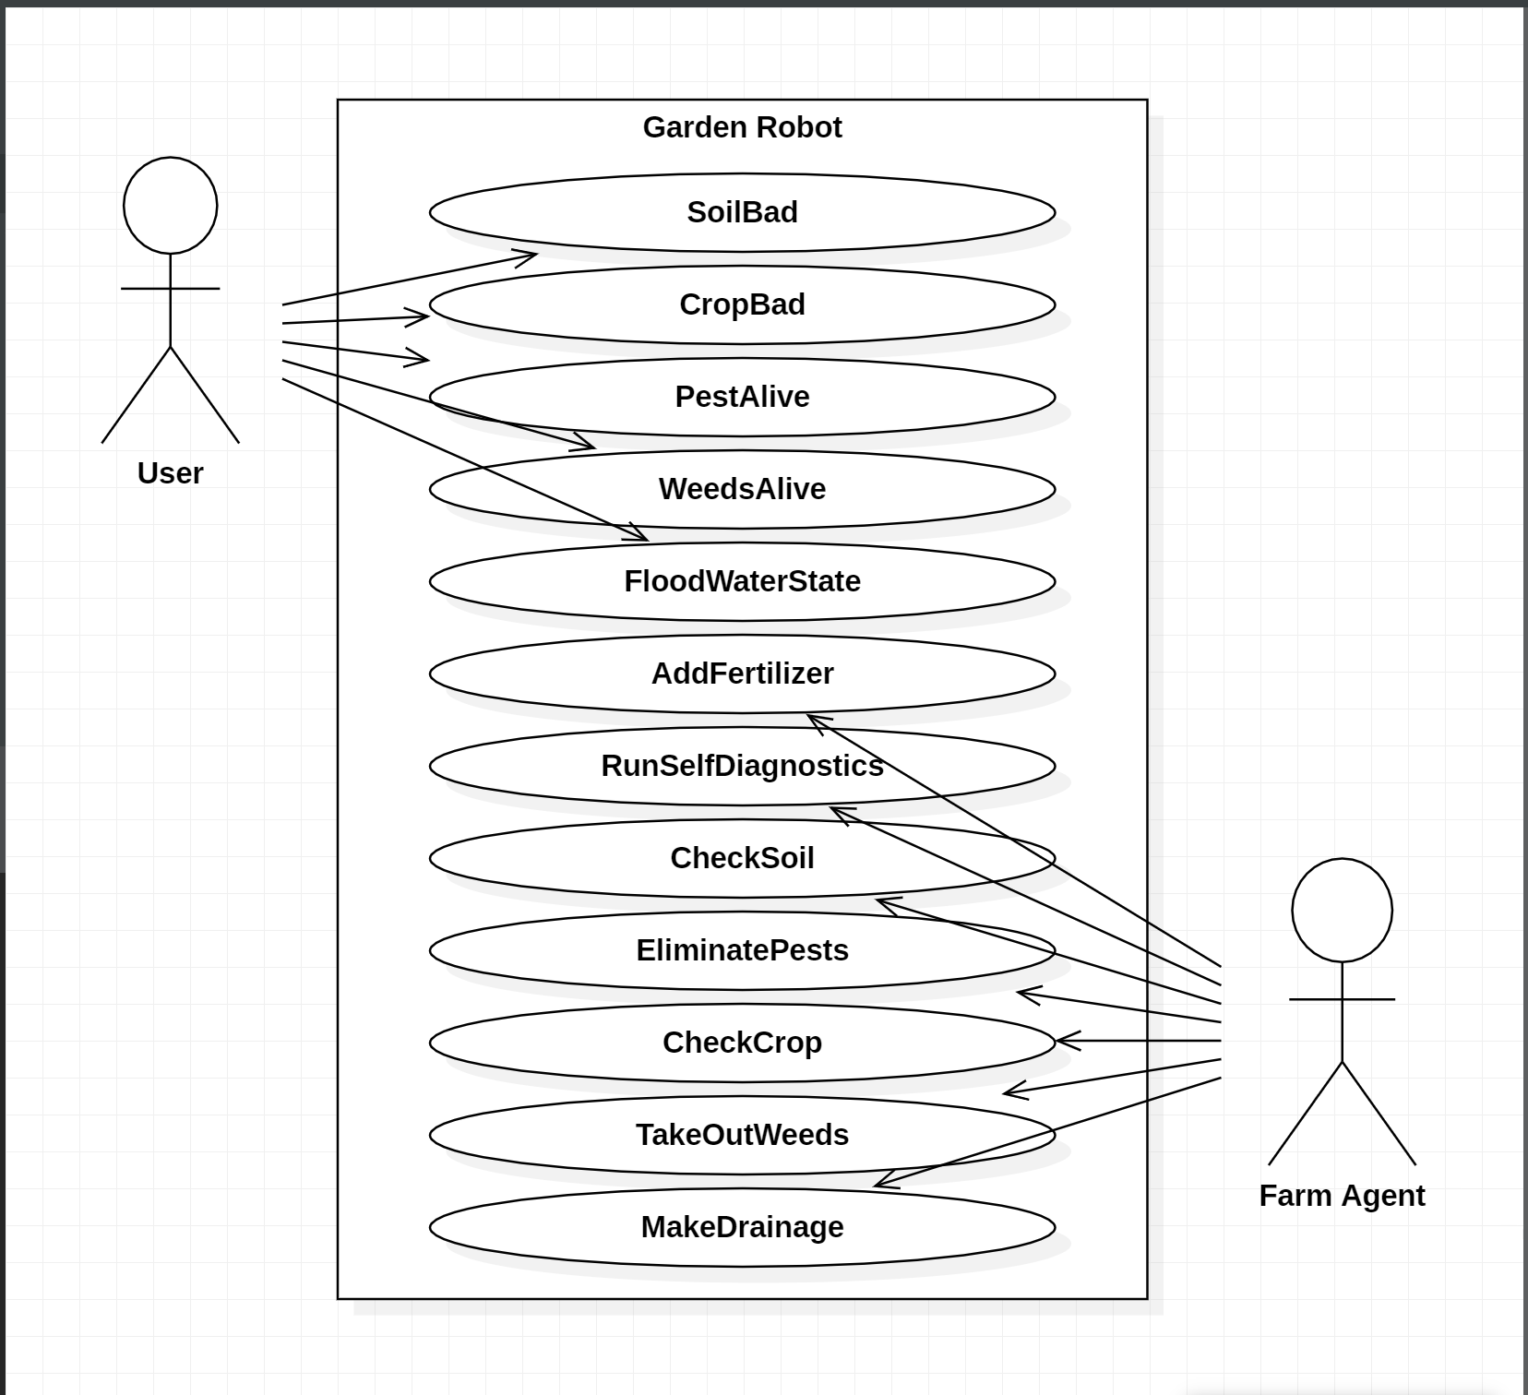

Figure 10. Use-case diagram.

## 4.4 Class design

This is the class diagram.

## 4.4.1 UML class diagram

This is the UML class diagram.

## 4.5 State Machines

**Patrol Field** – Pathfinding the field area (If plant found > Check Ground Soil)

**Check Plant State** (What is the stage of the plant?

Grow > Watering

Develop > Watering

Blossom > Watering

Fruitful > Harvest

Dead Plant > Take Dead Plant > Check Ground)

**Check Ground/Soil**: Check the Soil

Has seeds? No > Sow Seeds. Yes > Hazard Check

If Hazardous soil is found:

**Check hazard**

Else > Check Plant State)

Watering: Water plant/soil

Check Hazards ( Dry soil > Watering, Bugs or Animals > Pesticide)

Harvest: Fruitful harvest fruits.

## 4.6 State transition table

The state transition table for the various entities are below.

State transitions table for the agent.

|  |  |  |
| --- | --- | --- |
| **State** | **Transition** | **New state** |
| Patrol | Agent health <= 25 | System Repair and Diagnostic |
| System Repair and Diagnostic | Agent health > 99 | Patrol |
| Patrol | E is pressed | Flooding |
| Flooding | Scale x,y,z <= 0.0001f, 0.0001f, 0.0001f | Patrol |
| Patrol | P is pressed | Control Pests |
| Control Pests | Pests eliminated == true | Patrol |
| Patrol | W is pressed | Control Weeds |
| Control Weeds | Weeds eliminated == true | Patrol |
| Patrol | S is pressed | Check Soil |
| Check Soil | Soil colour change to brown | Patrol |
| Patrol | C is pressed | Check Crop |
| Check Crop | Crop colour change to green | Patrol |
| Patrol | G is pressed | Harvest crop |
| Harvest crop | Fruit harvested == true | Patrol |

Table 6. Agent state transition table.

Supported key input table

|  |  |
| --- | --- |
| Keyboard key | Description |
| S | Soil will change colour from dark brown to black showing there's no nutrient in the soil then the agent will change sate to "add nutrient" which will change it back to dark brown. |
| C | Crops will have fruits then the agent will change state to "harvest fruits". |
| W | This will bring out the weeds which normally harms the crop by slowly absorbing all the soil nutrient. |
| P | Pests will attach themselves to the crops and crops will change colour to black to show it is dying then agent will change state to "Kill pests" and "add nutrients". |
| E | Flood will elevate then the agent will change state to "drain flood". |
| Arrow-Down | This drops the agent’s health every time you press it. When the health gets to 25% the agent runs system diagnostic and brings itself back to 100%. |
| G | This key shall speed up the growth of the fruit and when the agent sees the fruit is matured enough, it harvest them. |

Table 7. Supported key input.

## Reflections / challenges identified

**The challenges highlighted in this section are for Crop detection and harvesting.**

The biggest challenge for this agent is the weather because the flood will make the soil slippery which means it will use more power during this time to force itself while making drainage channel the flood out of the farm. The crop analysis is limited to only checking the soil, the stem and fruit colour, and how hollow the fruit is. There isn’t further checks such as the mass of the fruit while it is still attached to the stem or how soft the flesh of the fruit are because doing these the agent might crush the fruit.

When the weather gets bad, there could be loss of connection between the control room and the agent in the field which means the agent will not be able to harvest the crops because it does not know where the crops are because it uses GPS to locate them, the agent will not know where the store house and laboratory are because it also uses GPS to locate them.

# References

A. I. Setiawan, T. Furukawa and A. Preston, 2004. *A low-cost gripper for an apple picking robot.* s.l., s.n., pp. 4448-4453.

A. Silwal, J. R. Davidson, M. Karkee, C. Mo, Q. Zhang and K. Lewis, 2017. J. Field Robot.. In: *Design integration and field evaluation of a robotic apple harvester.* s.l.:s.n., pp. 1140-1159.

C. Snyder, 2018. *Suites of 4R Nitrogen Management Practices for Sustainable Crop Production and Environmental Protection.* Norcross, GA, USA: s.n.

D. Bulanon, 2000. *Estimating of apple fruit location using machine vision system for apple harvesting robot.* s.l., s.n., pp. 540-545.

D. K. Ray, N. D. Mueller, P. C. West and J. A. Foley, 2013. *Yield trends are insufficient to double global crop production by 2050.* s.l.:PLoS ONE.

D. M. Bulanon, T. Kataoka, H. Okamoto and S.-I. Hata, 2004. *Development of a real-time machine vision system for the apple harvesting robot.* s.l., s.n., pp. 595-598.

D.-Y. Kong, D.-A. Zhao, Y. Zhang, J.-J. Wang and H.-X. Zhang, 2010. *Research of apple harvesting robot based on least square support vector machine.* s.l., s.n., pp. 1590-1593.

FAO, 2022. The State of Food and Agriculture 2022. *Leveraging agricultural automation for transforming agrifood systems*, p. 182.

Ian Sommerville, 2016. Software Engineering. In: *Layered Architecture.* Tenth edition, Global edition. ed. s.l.:Pearson Education, pp. 177-179.

IEEE, 20 July 2009. IEEE STD 1016-2009. In: *IEEE Standard for Information Technology--Systems Design--Software Design Descriptions.* s.l.:IEEE, pp. 1-35.

Iuliia Gapunenko, 2022. *Web development methodologies and approaches.* [Online]   
Available at: https://www.adcisolutions.com/knowledge/web-development-methodologies-and-approaches  
[Accessed 26 2022 November 2022].

J. Baeten, K. Donné, S. Boedrij, W. Beckers and E. Claesen, 2008. Field and Service Robotics. In: *Autonomous fruit picking machine: A robotic apple harvester.* Heidelberg: s.n., pp. 531-539.

John Sharp, 2022. Microsoft Visual C# Step by Step. In: *The List<T> collection class.* 10 ed. s.l.:Pearson Education, Inc., p. 569.

Lucas Wittstruck, Insa Kühling, Dieter Trautz, Maik Kohlbrecher, Thomas Jarmer, 2020. *settingsOrder Article Reprints.* s.l.:Sensors. 2021.

National Oceanic and Atmospheric Administration, 2023. *What is lidar?.* [Online]   
Available at: https://oceanservice.noaa.gov/facts/lidar.html#:~:text=Lidar%20%E2%80%94%20Light%20Detection%20and%20Ranging,Lighthouse%2C%20Dry%20Tortugas%2C%20Florida.  
[Accessed 25 January 2023].

NationalGeographic, 2023. *The Development of Agriculture.* [Online]   
Available at: https://education.nationalgeographic.org/resource/development-agriculture  
[Accessed 2023].

Roderick Burnett, 2020. *Understanding How Ultrasonic Sensors Work.* [Online]   
Available at: https://www.maxbotix.com/articles/how-ultrasonic-sensors-work.htm#:~:text=Ultrasonic%20sensors%20transmit%20sound%20waves,to%20return%20to%20the%20receiver.  
[Accessed 25 January 2023].

Sommerville, Ian, 28/03/2016. Software engineering. In: *Requirements Engineering.* s.l.:Pearson Education.

Sommerville, Ian, 28/03/2016. Software engineering. In: *Requirements Engineering.* s.l.:Pearson Education, p. 108.

Sommerville, Ian, 28/03/2016. Software engineering. In: *Architectural design.* s.l.:Pearson Education, p. 109.

Sommerville, Ian, 28/03/2016. Software engineering. In: *Requirements Engineering.* s.l.:Pearson Education.

Sommerville, Ian, 28/03/2016. Software Engineering. In: *Functional and non-functional requirements.* s.l.:Pearson Education, p. 105.

T. Bruulsema, 2017. *4R Phosphorus Management Practices for Major Commodity Crops of North America.* Norcross, GA, USA: s.n.

T. Krill, 1994. *An introduction to site specific management.* s.l.:Agricult. Finance Seminar.

T. Yield, 2019. *End-to-End Farm Sensing Analytics & Apps for Faster More Informed Decision-Making.* s.l.:s.n.

W. Mao, B. Ji, J. Zhan, X. Zhang and X. Hu, 2009. *Apple location method for the apple harvesting robot.* s.l., s.n., pp. 1-5.

Z. De-An, L. Jidong, J. Wei, Z. Ying and C. Yu, 2011. *Design and control of an apple harvesting robot.* s.l., s.n., pp. 112-122.